1. Explain test plan and test strategy difference.

Test Plan is a Detailed Document authored by QA comprising of Testing Processes, Testing Approach, Objective of the Test, Timeline / Estimate of the Testing to be conducted

Test Strategy basically is a Testing Process performed by QA

2. What fields do you need to define before you start writing test cases? (ex. Test Case ID)

My Test Case has the following Fields
- Test Case Number
- Test Title
- Test Steps
- Expected Result
- Actual Result
- Status (Passed / Failed / Pending / Not yet Tested)
- Bug Ticket Number

3. Please write the test cases for the below application.

Please refer to the excel file attached for the test case of the below application
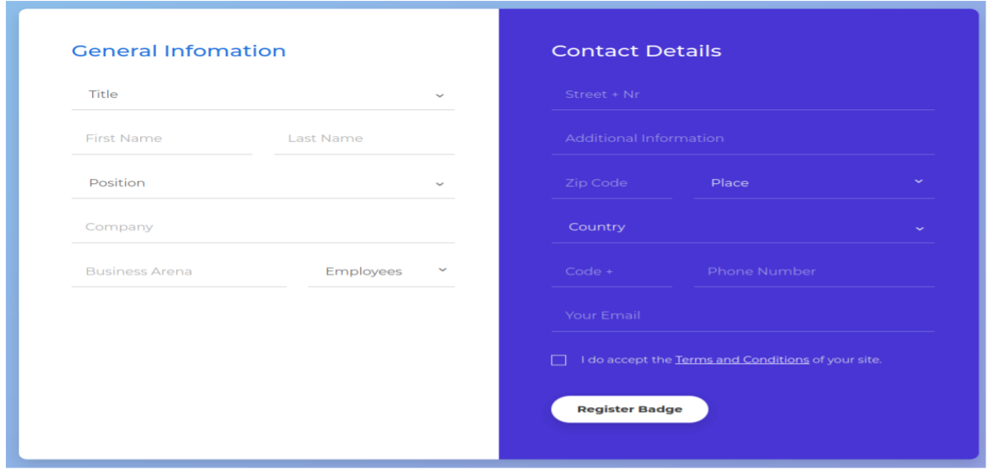

4. A part of the above application can utilize automation script. Please share where and why.

Automation #1
When modifying Information entries of an existing personnel. Upon providing the primary full name, the below must be in automation.
  - Auto-Population for current secondary fields from "General Information" for possible modification.
  - Auto-Population for current "Contact details" information for possible modification.
  - Auto-display of current badge.
  - Auto-display of last modification done.

Automation option #2 (Bulk)
We put all the information fields values the on a csv comma delimited file. one record each. Pass it to a facility that Dev will be providing, Reading the csv file entries one by one and entering to the db itself. As an insert or an update.

5. Choose ONE and provide your answer,
a. write the automation script (per Q4) using Python or Java
b. provide specific technical details how you would go through this test activity (step by step process)

I am choosing B -
For the Testing Strategy / Process, my approach is Proactive Approach
1. start with gathering needed references to start with my Test Plan Creation &Test Script / Test Cases
2. make sure to Provide multiple Test Phases / Cycle
3. do Regression Testing of the whole system whenever Bug Fixes by the Developer are done. It is also a preventive way or approach to achieve minimal to zero bugs when system/project is deployed to production.

I follow this Test Life Cycle
- defining Test Strategy wherein it always is Manual Testing
- start Test Documentation (test plan/test script or cases/data)
- start testing execution the moment I got go signal from dev team that QA / Testing Server is already up for testing (this also includes test reports)
- after coming up with defects/bugs, bug fixing and bug tracking - retesting of the bug defects will be conducted as well as regression of the whole system to make sure no other module or feature is touched during bug fixing by developers
- after Qa / Testing Server passed QA, it is now ready for UAT with client or person-in-charge in Pre-prod Server

